**Task Lists**

**1) Reviews page** - <http://bring8.com/demo/restaurants/thai-rest/details>

Please update this with the design something like

<https://drive.google.com/open?id=11UmzSUbPmIPvAeDsHDqvPgNRUY68Cx7z>

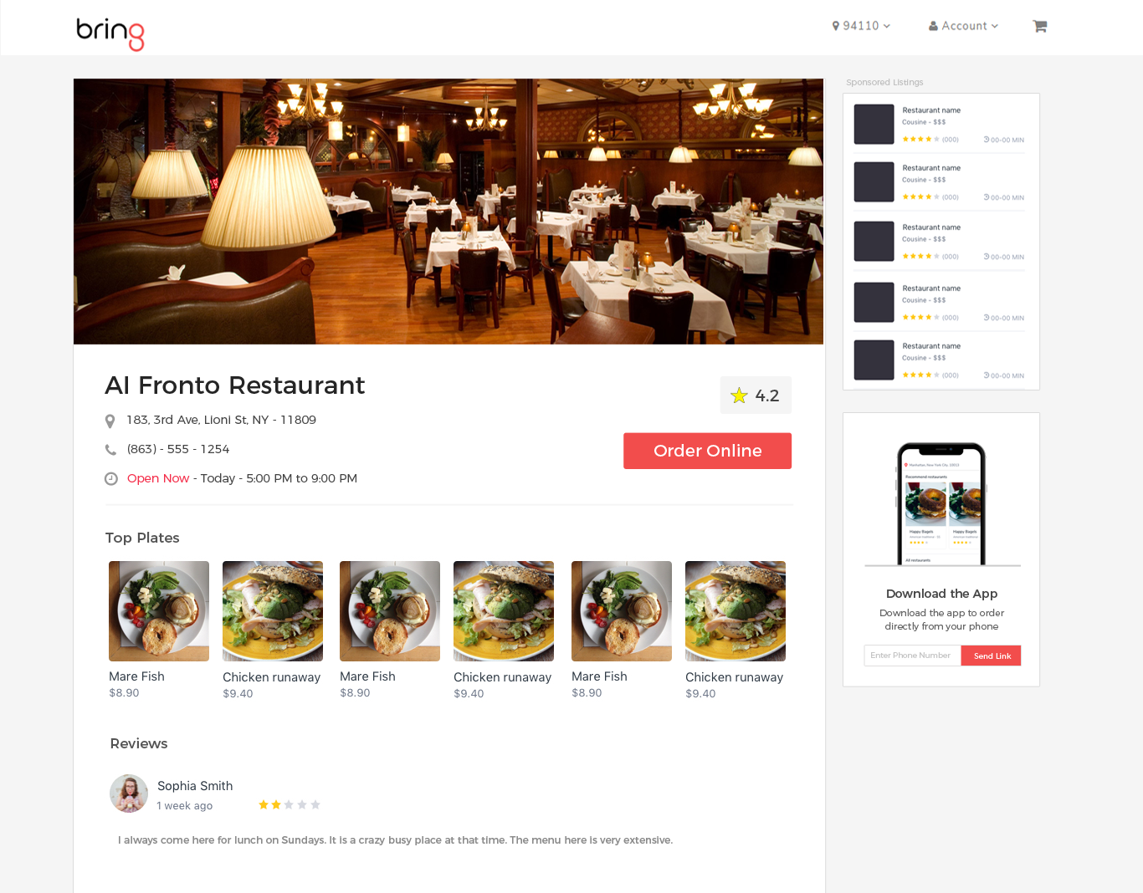

If you want the PSD file then download it from here - https://drive.google.com/open?id=1ToljAclNifjagmDUOugY0JFOTnnhklgH

**Sub tasks**

Most of the things of this page are already done.

1. Add 5 star rating to **reviews** (Use the already available css codes from internet). You might need to spend some time in getting the codes.
2. Create the “Download APP” section with input box. For the “input box” you will already have the codes.

**2) Online Ordering list page -** [**http://bring8.com/demo/restaurants/thai-rest**](http://local.bring8.com/demo/restaurants/thai-rest)

**Sub Tasks**

1. Make the menu - “Main Dishes”, “Pizza” scrollable something like -

Open this website in 1024px width - <https://www.fortyeighteast.com/>

You will have arrows in the categories which enables you to scroll down the menu.

**3) New page - Contact Support Page**

Use this page - <https://munchery.com/support/> to take the inspiration in fact you can almost copy it as well. Just use the previous fonts what we are using.

**4) New page - Simple Login Page for Restaurants**

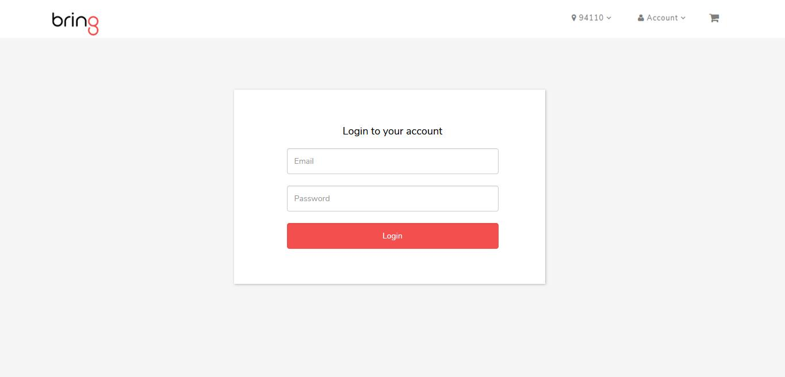

Simple Copy Paste of current login input box. Open - [http://bring8.com/demo/](http://local.bring8.com/demo/restaurants/thai-rest) and click on “Login” a modal will open. Use inspect element and copy the HTML.

**5) New Page [Need some designing as well] - Order Details Page**

---- Will update this one ---